iNeuron

Insurance Premium Predictor

Wireframe

**Homepage**

The user first is welcomed to the homepage as below:

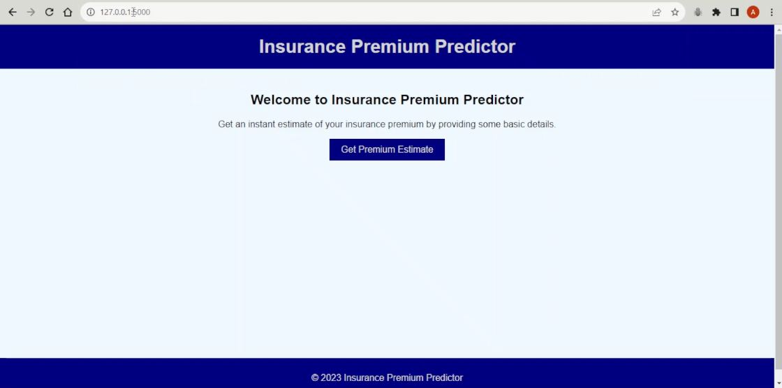

The user then proceeds to the details page, which can be accessed by a Simple click on the **Get Premium Estimate** button as below.



Upon clicking on the button, the user sees the Details/Information page which is required for predicting the premium.

**Details Page**

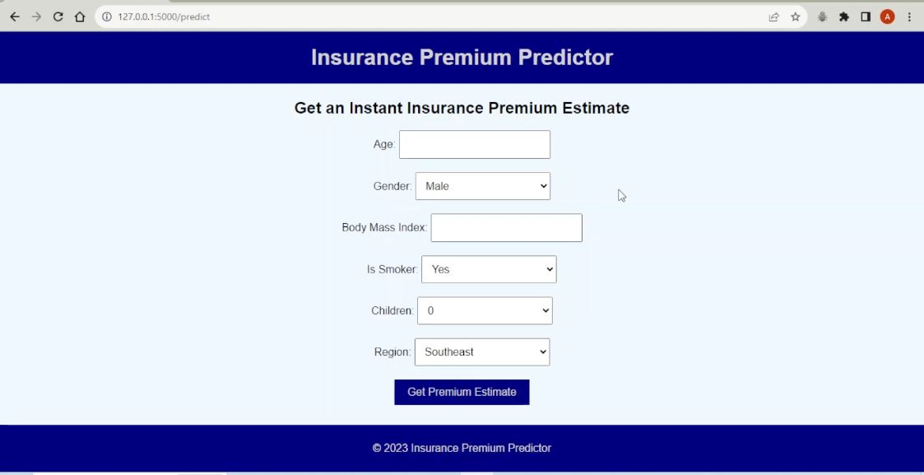

Then the user proceeds to fill in the necessary details and then click on **Get Premium Estimate** button.

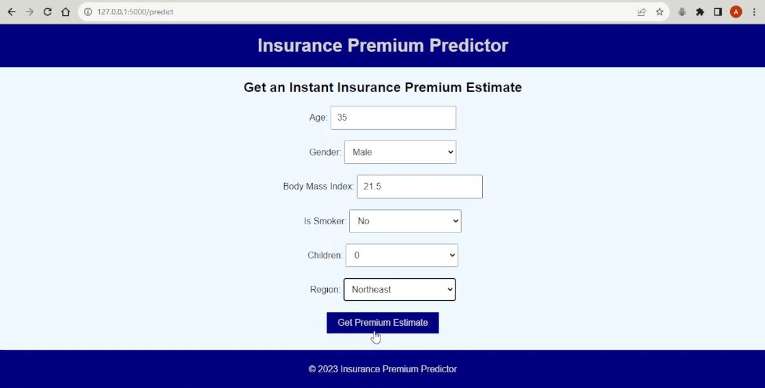

The user is finally forwarded to the Prediction page, where the amount of predicted premium is displayed.

**Prediction**

